2023年10月第3週　高校生ニュース教材　単語テスト　　　　　 　　　

音声を聴いて、次の単語（熟語）を書きとって下さい。また、その意味を日本語で書いて下さい。

|  |  |  |
| --- | --- | --- |
|  | words/phrases | meaning |
| １ |  |  |
| ２ |  |  |
| ３ |  |  |
| ４ |  |  |
| ５ |  |  |
| ６ |  |  |
| ７ |  |  |
| ８ |  |  |
| ９ |  |  |
| １０ |  |  |
| １１ |  |  |
| １２ |  |  |
| １３ |  |  |
| １４ |  |  |

・・・・・・・・・・・・・・・・切　り　取　り　・・・・・・・・・・・・・・・・・・

1. Israel 　　 　　　　　イスラエル ［ɪ́zriəl］ 形容詞はIsraeli［ɪzréɪli］
2. Palestine 　 　　　　　　パレスチナ
3. Jewish　　　　　　　　　　　　　　　　　　ユダヤの、ユダヤ人
4. the Gaza Strip 　　　　　　ガザ地区　　＊strip：細長い地区
5. the Middle East 中東
6. launch 　　　　　= start
7. death toll 　　　　　死亡者数
8. hostage 　　　　　人質
9. in retaliation for ～　　　　　　～への報復として
10. fuel 燃料
11. conflict 紛争
12. civilian 民間人
13. casualty 負傷者・死者
14. intelligence 諜報機関 ※知能・知性の意味も

Israel and Palestine

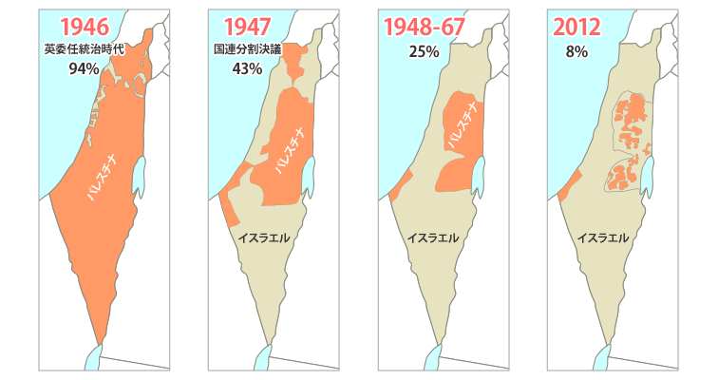　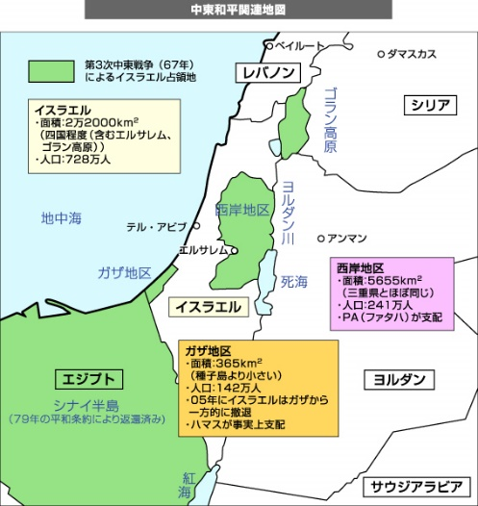

地図：　<https://ccp-ngo.jp/palestine/>

外務省HP：　<https://www.mofa.go.jp/mofaj/press/pr/wakaru/topics/vol15/index.html>

|  |  |  |
| --- | --- | --- |
|  | Israel | Palestine |
| capital city | Jerusalem （Tel Aviv）　＊１ | Ramallah |
| people | Jewish(74％), Arabs(21％) | Arabs |
| religion | Jewish(75%), Muslims(17.5％),  Christians(2%) | Muslims(92%), Christians(7%) |
| Language | Hebrew | Arabic |
| Area | 22,000 km2  （日本の四国くらい） | 約6,020km2  １）West Bank(西岸地区) 5,655 km2  （三重県くらい）  ２）Gaza Strip（ガザ地区）　365 km2  （福岡市よりやや広い） |
| Population | 9.23 million | 4.97 million |
| GDP per capita | 43,641 dollars | 2,894 dollars |
| unemployment rate | 4.6% | 32% |

＊イスラエルは2017年に首都をテルアビブからエルサレムに変えると宣言し、首相官邸や国会もここにある。だが日本外務省HPの首都欄には「エルサレム」とあるものの、「日本を含め国際的に認められていない」と注釈がついている。日本を含め国際社会の多くが「首都＝エルサレム」と認めておらず、各国の大使館はテルアビブにある。

★イスラエルとパレスチナを比較し、気づいたことを発表しましょう。

Hamas Attack on Israel

１　On the morning of October 7th, Hamas, the terrorist group ruling the Gaza Strip, launched ①a surprise attack on Israel.  It fired a barrage of rockets into Israel, and more than 1,300 Israeli people have been killed, including 25 Americans. The death toll will undoubtedly rise. Over 3,000 are critically wounded, and over 200 hostages have been taken into the Gaza Strip.**The hostages** include women, children and foreigners.

２　Israel has conducted airstrikes on the Gaza Strip in retaliation for a savage and inhumane incursion by Hamas. According to *Aljazeera*, at least 1,537 Palestinians, including 500 children and 276 women, have been killed in Gaza as of October 11th. Israel also sealed Gaza off from food, fuel and other supplies. Hamas escalated the conflict, pledging to kill hostages if Israel attacked civilians without warnings.

３　“We have only started striking Hamas,” Israeli Prime Minister Benjamin Netanyahu said in a nationally televised address. ②“What we will do to our enemies in the coming days will reverberate with them for generations.”

４　“We stand with Israel,” the U.S. President Biden said in an address on October 10th. He said dozens of Americans have been killed and taken hostage by Hamas. He promised he would support Israel with whatever it needs in its fight against Hamas. He also said his priority is the safety of American hostages.

５　 When Hamas attacked Israel last week, all but one G7 governments immediately expressed that Israel had a right to defend itself. Only Japan condemned the Hamas attacks, but also expressed concern over the number of casualties in the Gaza Strip caused by the Israel Forces. Prime Minister Kishida posted on X, "All the parties concerned should exercise maximum restraint."

a barrage of ～：～の集中砲火 rocketロケット弾　　　conduct実行する　　　　airstrike空爆　　　　savage野蛮な　　　　inhumane非人道的な　　　incursion侵略　　　as of ～：～の時点で　　　　seal-off：-を封鎖する　　　escalate悪化させる　　　pledge誓う　　　warning警告　　reverberate反響する・影響を与える　address演説　　　dozens of ～：数十の～　　condemn非難する　　concern懸念　　force軍隊　 maximum最大限の　　restraint自制 ★( 　　　　　　　　　　　　　　　　　　)

Q1　What is ①a surprise attack?

Q2 Is Hamas the official government of Palestine?

Q3 イスラエル・パレスチナの被害状況（死者、けが人、人質の数）を説明しましょう。

Q4　What did Israel do to Palestinians in retaliation? Write more than two things.

Q5 How did Hamas escalate the conflict?

Q6 下線②のイスラエル首相の言葉を訳しましょう。

Q7　Which side of the war does the U.S. support? Why?

Q8 After the Hamas attack, what did G7 governments express except for Japan?

Q9 岸田首相は(1)誰に向けて懸念を表明しましたか。また、(2)何とツイートしましたか。

６　Hamas stands for the Islamic Resistance Movement. Hamas has been in power in the Gaza Strip since 2007. More than two million people live in Gaza, one of two Palestinian territories.

７　There is one question: “（③なぜイスラエルの諜報機関は、ハマスの攻撃の予測に失敗したのだろう？）” Israel's Intelligence Agency, known as Mossad, is considered one of the best in the world due to its highly skilled personnel and advanced technology, including surveillance equipment and cyber capabilities. It has agents inside Palestinian militant groups, as well as in Lebanon, Syria and elsewhere in the world.

These allow the agency to gather and analyze information and take military actions (　　④　　). However, dozens of armed Hamas soldiers have crossed the border and invaded Israel.

８ The unprecedented attack on Israel by Hamas has raised new questions about the influence of the sponsor. It is a well-known fact that Iran has [supported](https://www.wilsoncenter.org/article/irans-rockets-palestinian-groups) Hamas financially by providing arms. But Iran’s supreme leader Ali Khamenei denied any Iranian involvement in Hamas's attack on Israel.

９　The attack was launched on Israel during the Jewish holiday of Simchat Torah, which begins at sunset on October 7th and ends after nightfall on October 8th. In addition, the Israel-Hamas war coincides with the 50th anniversary of the 1973 Arab-Israeli War.  
１０　Analysts say one of the triggers of Hamas attack is the prospect of a wider Middle East peace through an impending ⑤peace deal between Israel and Saudi Arabia with the U.S. acting as a mediator.

On September 22nd, Israeli Prime Minister Netanyahu announced, “Such a peace will go a long way in ending Arab-Israeli conflict and will encourage other Arab States to normalize their relations with Israel,” he said, adding that it will also enhance prospects of peace with the Palestinians.

predict予測する　　 personnel(複数扱い)隊員・職員　　　surveillance監視　 equipment設備 cyberネット上の

agent外交員・スパイ　　　analyze分析する　　　　armed武装した　　　invade～：～を侵略する　　　　unprecedented前代未聞の・前例のない　　　　supreme最高位の　　　deny否定する　　　involvement関与　　　 coincide with～：～と同時に起こる　　　trigger要因・きっかけ　　　　prospect見込み・見通し　　　impending近い将来の peace deal和平協定 mediator仲介者　　　go a long wayとても役に立つ normalize正常化する relation関係　　　　enhance高める

Q10　Regarding Hamas, (1)what does the name stand for? (2)How long has it ruled the Gaza Strip?

Q11　③の日本語を表すように、次の語句を並べ替えましょう。

［ intelligence / the Hamas attack / did / fail / Israeli / predict / to / why / ? ］

Q12 Give examples of Intelligence agencies in the world.

Q13 モサドの(1)諜報員　(2)設備　について説明しましょう。

Q14 下線④に入る語句として最も適切なものを選びましょう。

1. economically and financially 　　　　b) basically and fundamentally
2. unfortunately and tragically d) quickly and effectively

Q15 Who is the sponsor of Hamas? Did the sponsor support the attack on Israel?

Q16 10月7日は、何の記念日でしたか。２つ答えましょう。

Q17 専門家たちの分析によると、ハマスのイスラエル攻撃を誘発したのは、何ですか。

Q18　イスラエルのネタニヤフ首相によれば、下線⑤は何の実現に繋がりますか。３つ答えましょう。

１１　The leaders of the U.S, the U.K, Germany, France and Italy expressed support for Israel and its right to defend itself from attacks by Hamas on October 9th. Why have they had strong ties with Israel?

１２　First, Israel has a strong and innovative economy, particularly in the technology sector. USB memory sticks, capsule endoscopes, Firewall software, and cherry tomatoes were created in Israel. Israel is called the Silicon Valley of the Middle East because so many new technology companies got started there. Many Western countries see opportunities of economic collaboration, investment, and technological innovation by working closely with Israel.

１３　Secondly, Israel plays a significant role in the Middle East. Western countries need Israel as a strategic ally for geopolitical purposes in order to cope with regional security threats and terrorism.

１４　Meanwhile, EU ministers of Foreign Affairs held an informal video conference. The foreign ministers reiterated Israel’s right to self-defense, but they also discussed how to continue **to** support the Palestinians. They issued a statement: “We made a clear distinction between Hamas and the Palestinians. We consider Hamas a terrorist group, but the Palestinian authority is another thing. Not all the Palestinian people are terrorists. ⑥A collective punishment against all the Palestinians will be unfair and unproductive. We will support and work together with the Palestinians.”

tie繋がり・絆　　　　　innovative革新的な　　　endoscope内視鏡　　　　collaboration協力 investment投資　　　innovation発明　　　　　strategic戦略上重要な　　　ally同盟国 geopolitical地政学的な cope with-：-に対処する　　regional地方の reiterate強調する distinction違い・区別　　　　authority=government collective集団的な punishment罰　　　　unproductive非生産的な　　★( )

Q19　　イスラエルで発明された有名なものに、何がありますか。

Q20　　Why is Israel called the Silicon Valley of the Middle East?

Q21 欧米諸国がイスラエルとの関係を強くしたい理由を、２点説明しましょう。（12・13段落の内容をまとめましょう）

Q22　 EU外相会合が下線⑥のような声明を出した理由を答えましょう。

Q23 ［Opinion］Why is the role of mass media important during the war?

Q24 ［Opinion］Should news outlets show graphic images of war victims?

★次の文を３回ずつ読んで、暗唱しましょう。

１．Israel has conducted airstrikes on the Gaza Strip in retaliation for a savage and inhumane incursion by Hamas.

２．All but one G7 governments immediately expressed that Israel had a right to defend itself.

３． Israel's Intelligence Agency, known as Mossad, is considered one of the best in the world due to its highly skilled personnel and advanced technology.

４．“We consider Hamas a terrorist group, but the Palestinian authority is another thing.”

５．Not all the Palestinian people are terrorists.

１．イスラエルは、野蛮で非人道的なハマスの攻撃への報復として、ガザ地区への空爆を行った。

２．一国（日本）を除いて、G7諸国の全てが、イスラエルには自衛の権利があると表明した。

３．モサドとして知られている、イスラエルの諜報機関は、能力の高い諜報員達と高性能のテクノロジーにより、世界一の組織と考えられている。

４．「私達は、ハマスをテロ組織だと思っていますが、パレスチナ政府はそれと別です。」

　　★ A is one thing, and B is another. （意味：AとBは別です）

５．全てのパレスチナ人がテロリストではありません。

　　★部分否定：Not all ～. 　全てが～ではない。100％が～というわけではない。

［チャレンジ］★全面否定の英文を書きましょう。

「全てのパレスチナ人がテロリストではない（パレスチナ人のテロリストは、ゼロである）」

|  |  |
| --- | --- |
|  | ハマスがイスラエルに大規模攻撃　前例のない侵入［BBC Japan］  <https://www.youtube.com/watch?v=tXmvlLs0Lkc> |
|  | President Biden： “We stand with Israel”  10/11バイデン大統領は「我々はイスラエルを支持する」と言いました。  <https://www.youtube.com/watch?v=b10ymsjOF3w> |
|  | Hamas ‘don’t represent’ all Palestinian people: Joe Biden  しかし10/16　バイデン大統領は「ハマスはパレスチナの代表ではない」と言い、パレスチナの人々とハマスは違うことを強調しました。“What happened in Gaza, in my view, is Hamas and extreme elements of Hamas don’t represent all the Palestinian people,” he said. |
|  | 【解説】 ハマスの本格攻撃、イスラエルの反撃　これまでと何が違い今後への影響は  <https://www.youtube.com/watch?v=pk653WslgC0> |